Web Application Design Project

Front-End & Application Functional Requirements

-report-

**Theme:** Car Auction Website

For this project I used HTML, CSS, JavaScript and Bootstrap 5. In order to access Boostrap, I have included the links from the official page in the html files.

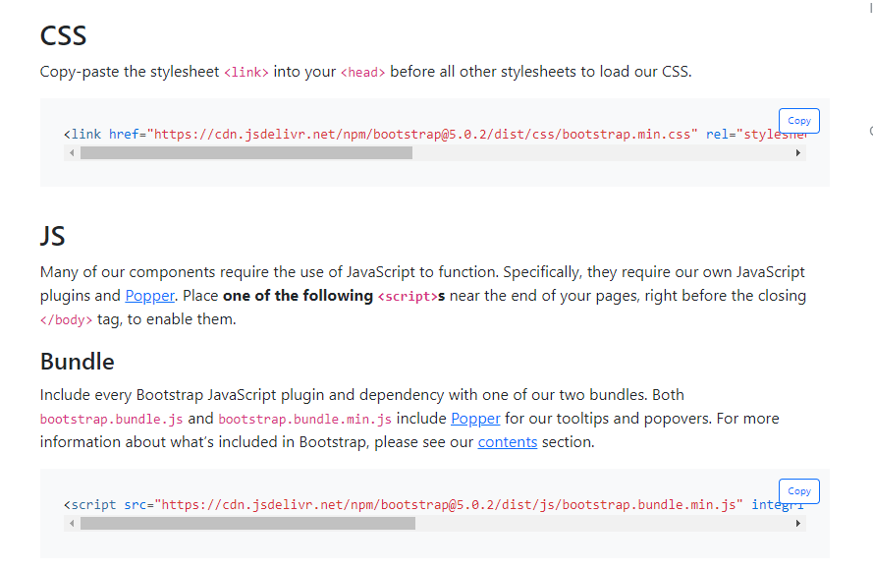

My current project consists of 6 html pages and 6 css files, each page having its own css file to beautify its appearance.

1. index.html , index_style.css– the Home page, which contains:

* navigation bar with the sections: name of the site, Home, SearchCars, Auctions, Sell, Contact, Register, Login

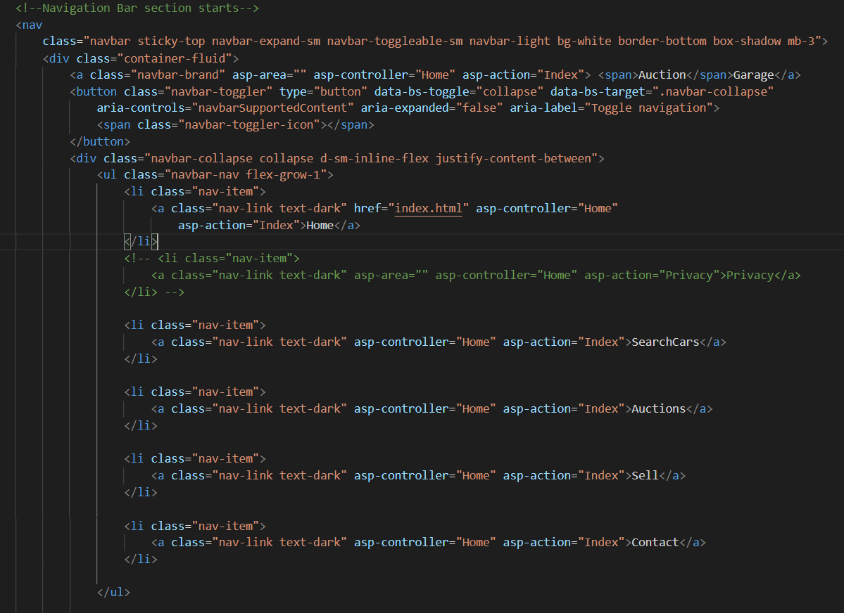

The default color of these items is black, but when you move the cursor over them, they change color, which is done in the css file, **index_style.css,** using hover.

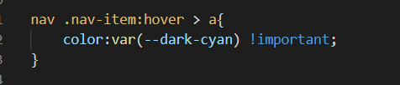

* home section contains the title, a picture, and a button that moves when the cursor hovers over them and returns to their original state when the mouse is no longer in that area.



This is possible with the help of two functions written in the javascript file, **script.js:**

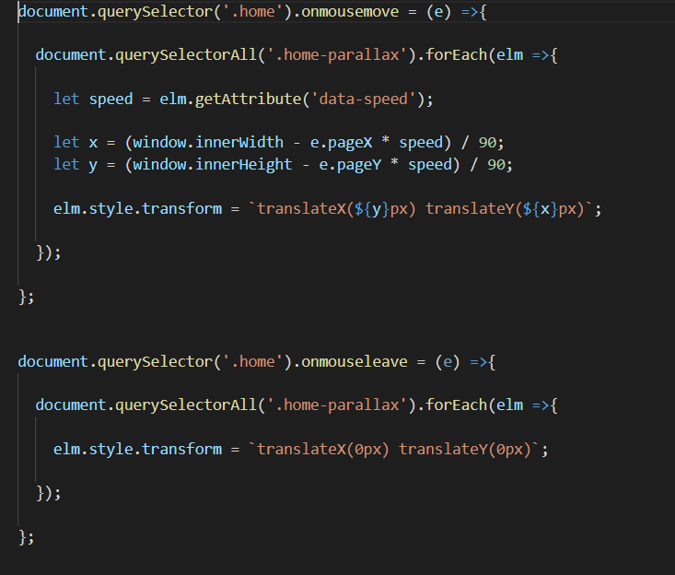

* ReasonsToBuy section contains a container with 3 cards about the advantages of the company, which is made in Bootstrap, and a button which links people to a page with more information about AuctionGarage.

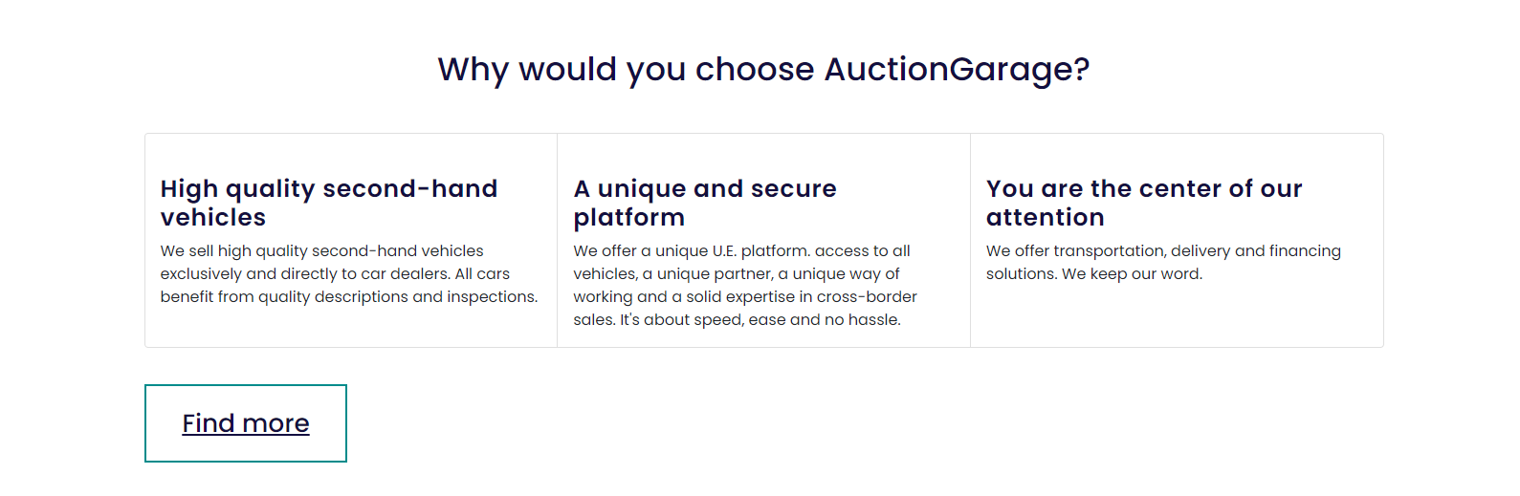

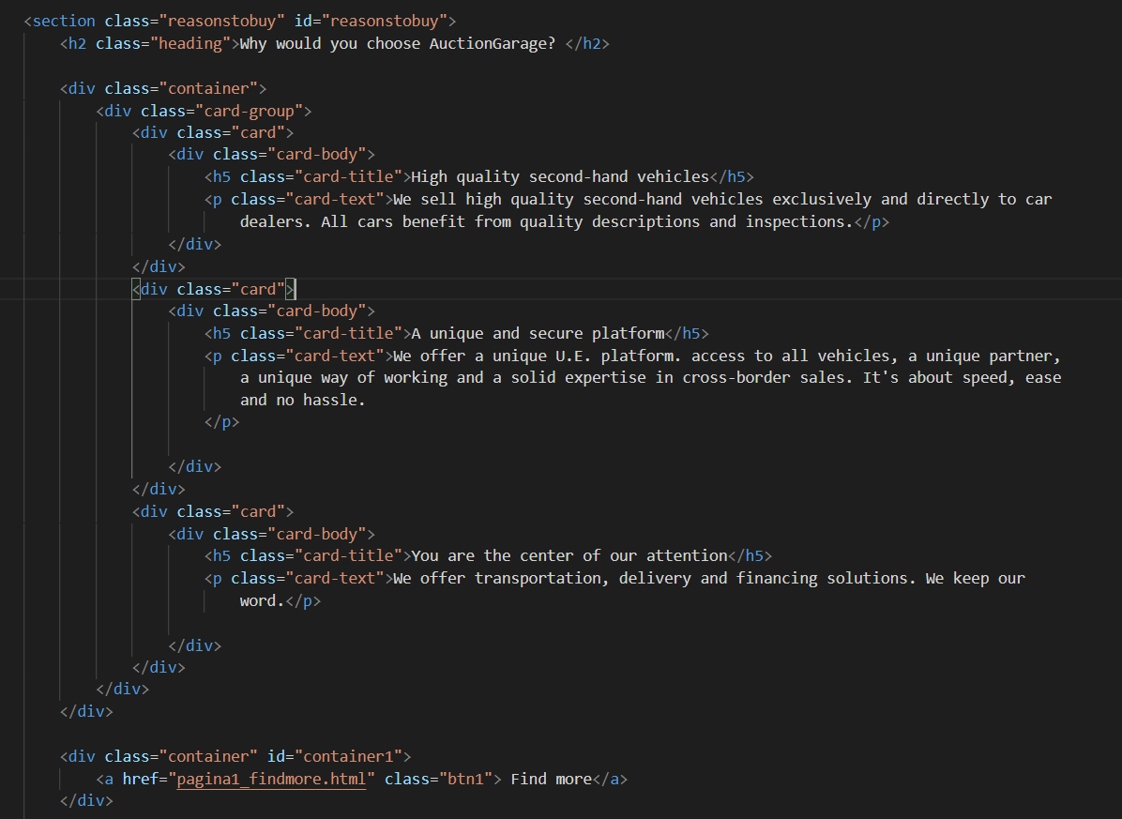

* The vehicles section, as well as the ReasonsToBuy section, contains a container with 6 cards, 3 per 1 in a row, about the most popular cars and some information about them. Each card has a "Check Out" button to find out more about the car.

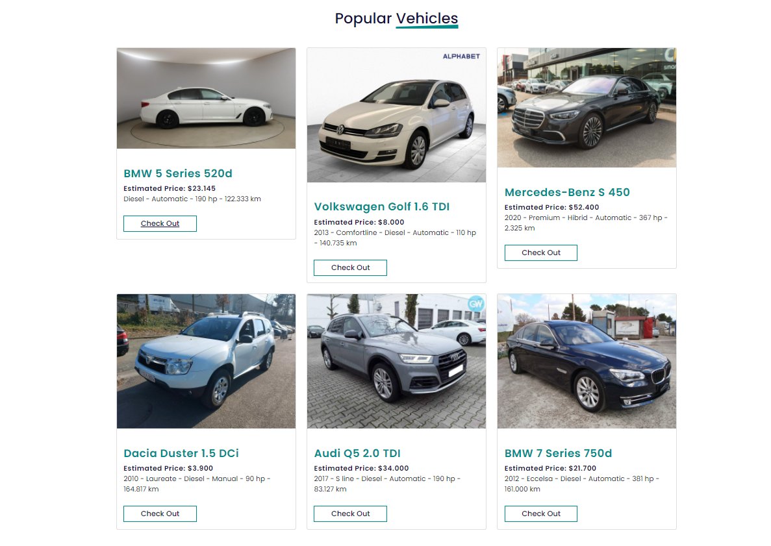

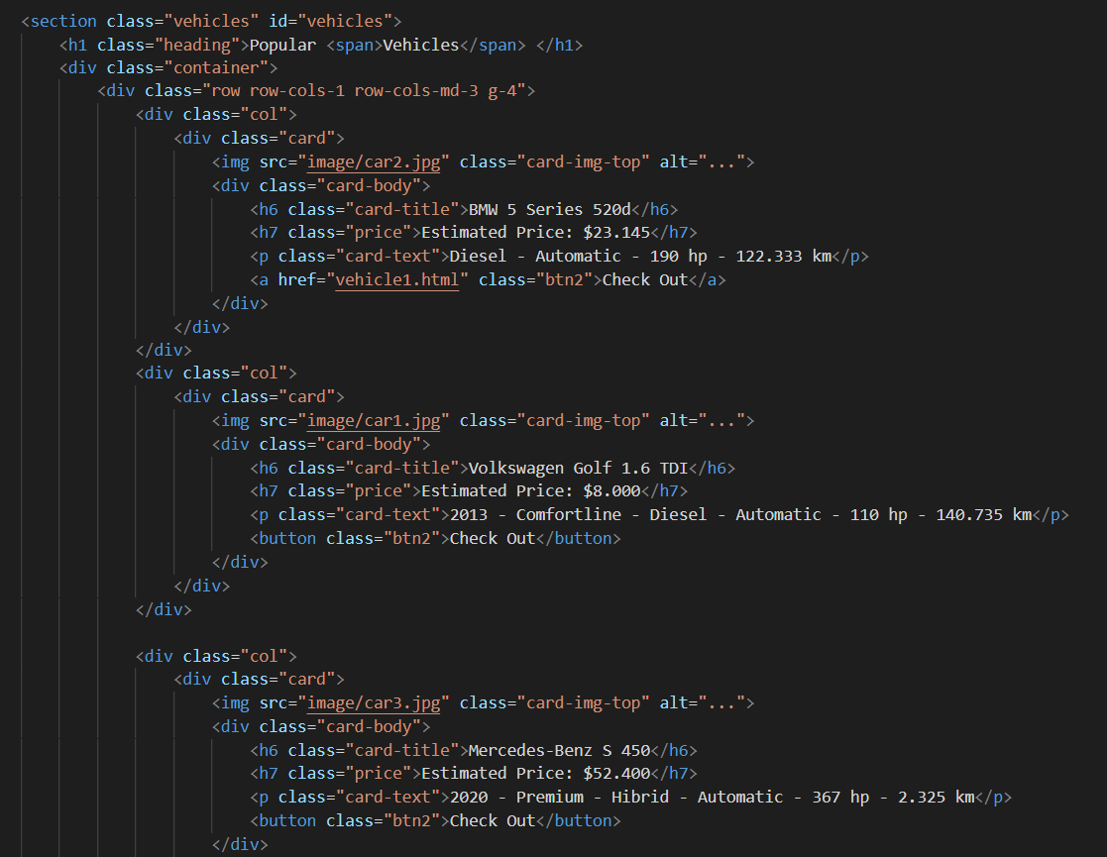

* Newsletter section

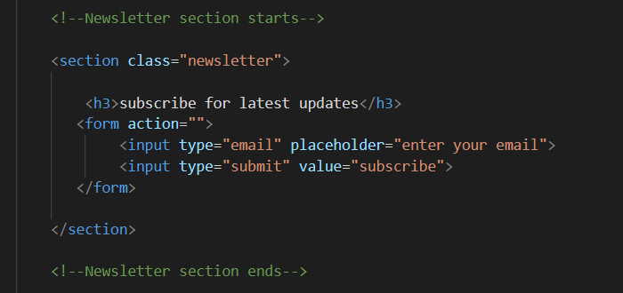

* Footer section

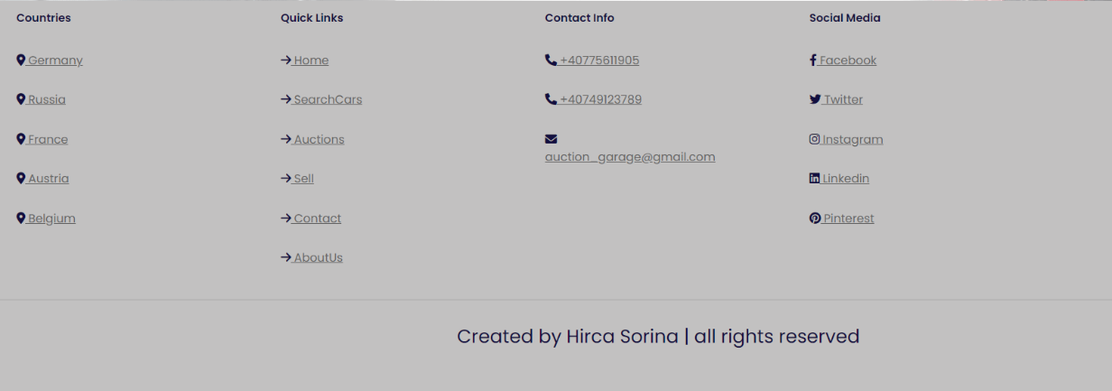

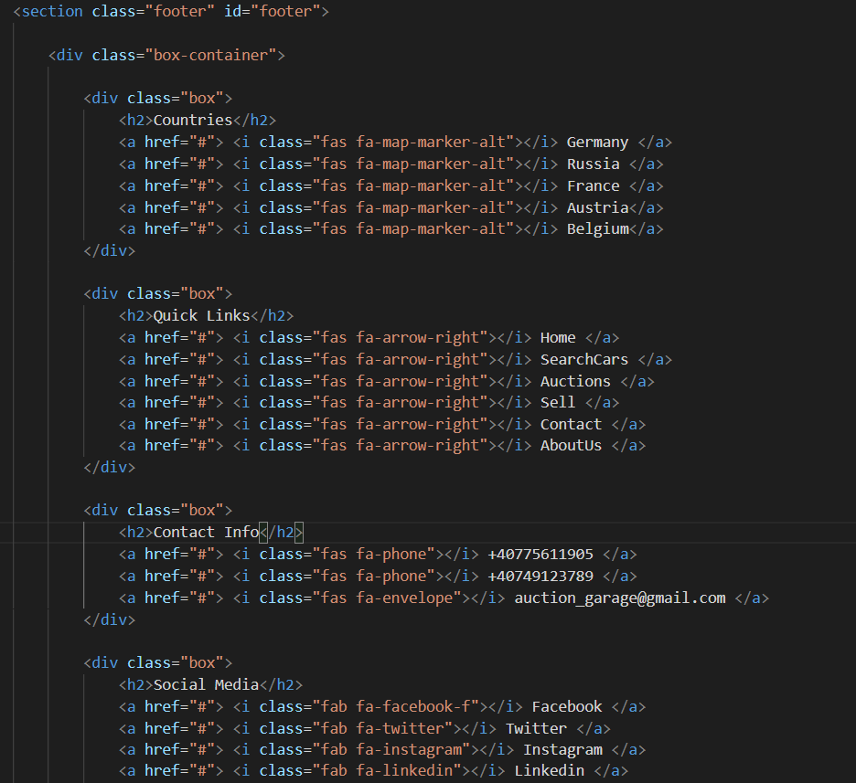

I introduced the Font-Awesome library to access the footer logos:

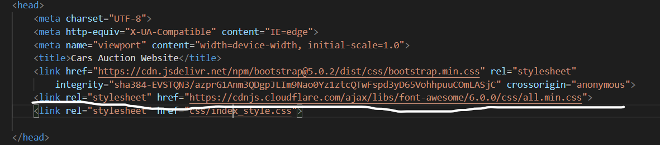

1. register.html and login.html (Register and Login pages) – register_style.css and login.style.css

Both pages are made in the same style: a container containing a card centered in the middle of the page, each with several fields for user information. Each page is linked to the other.

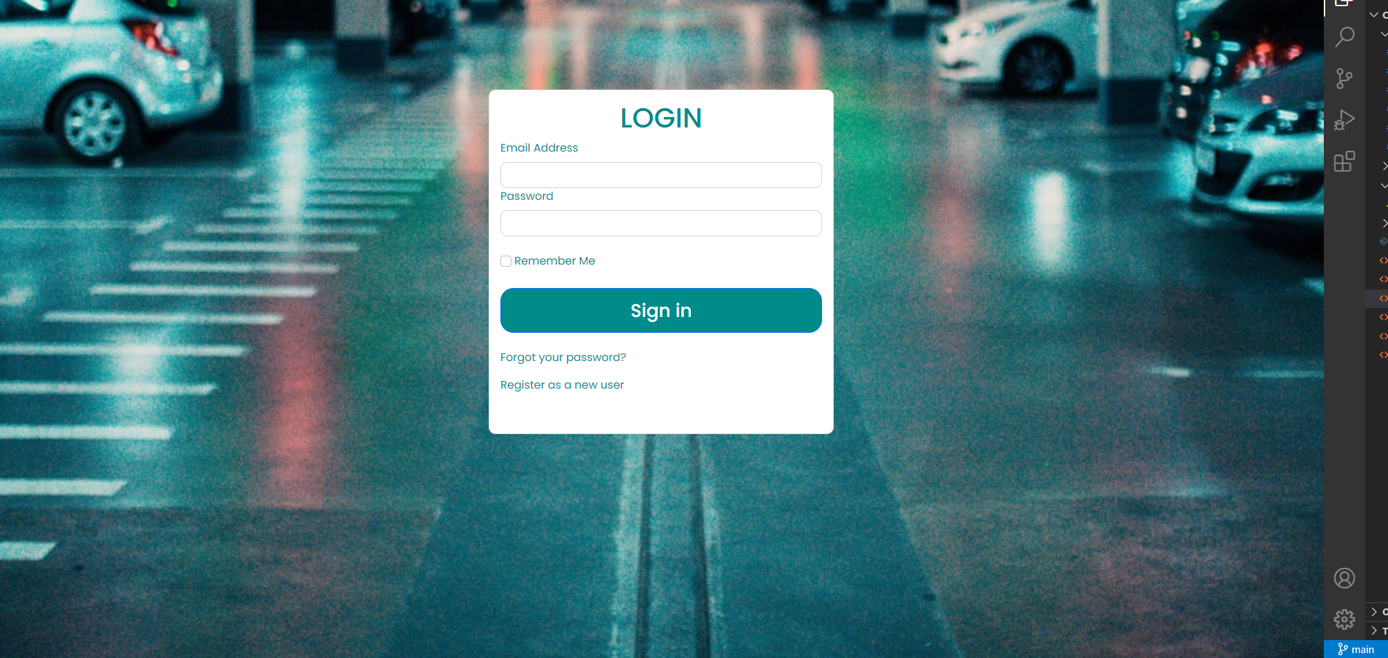

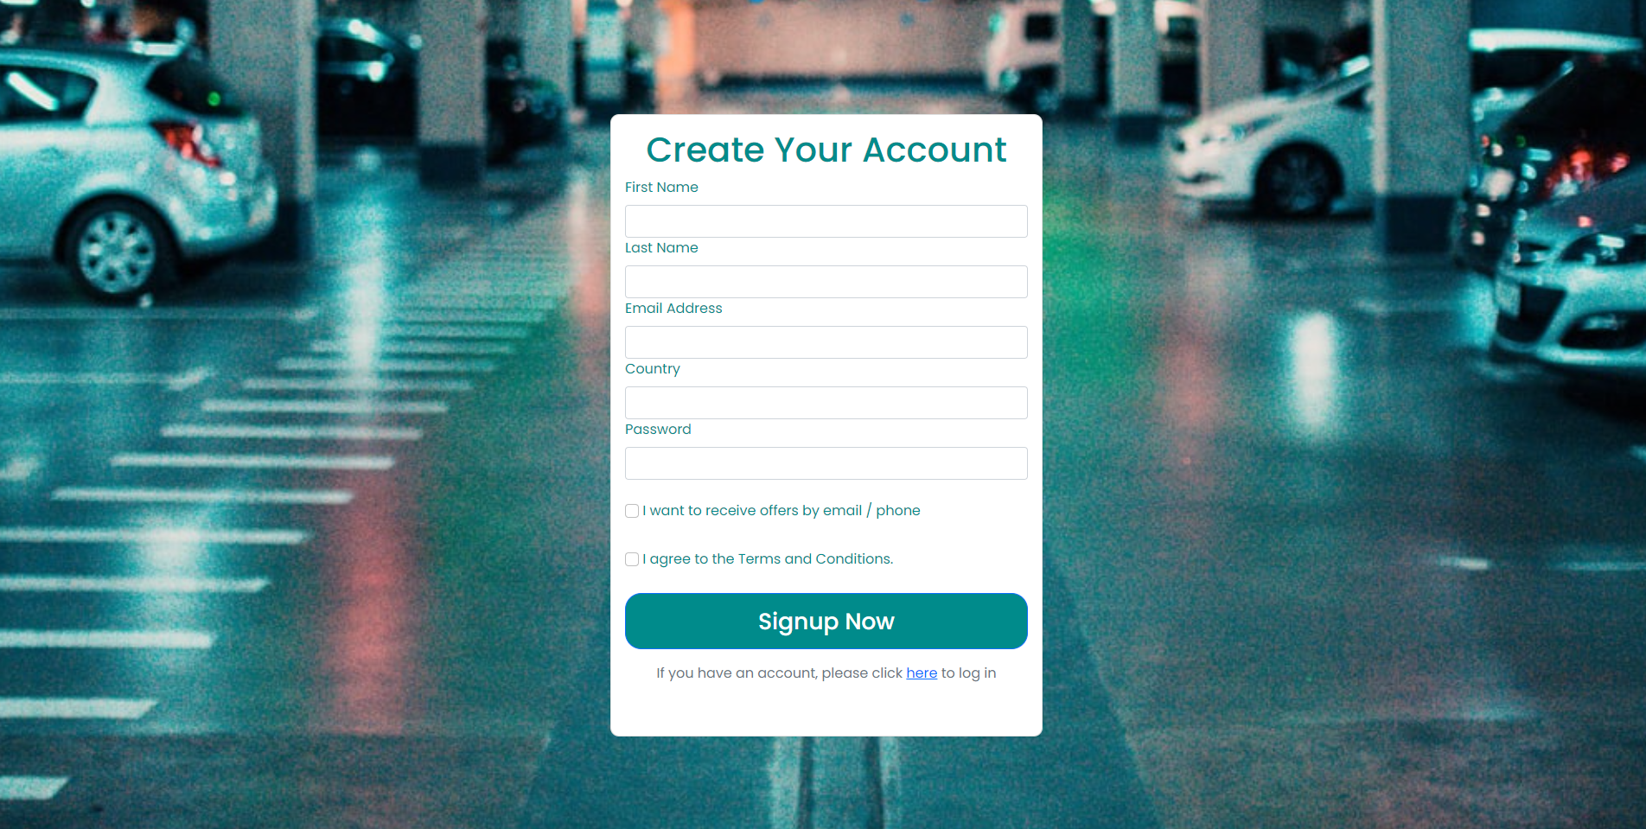

 <!--Login starts-->

    <div class="global-container">

        <div class="card login-form">

            <div class="card-body" width="480px">

                <h1 class="card-title text-center">LOGIN</h1>

                <div class="card-text">

                    <form>

                        <div class="form-group">

                            <label asp-for="Input.Email" class="form-label">Email Address</label>

                            <input asp-for="Input.Email" class="form-control" autocomplete="username"

                                aria-required="true" />

                            <span asp-validation-for="Input.Email" class="text-danger"></span>

                        </div>

                        <div class="form-group">

                            <label asp-for="Input.Password" class="form-label">Password</label>

                            <input asp-for="Input.Password" class="form-control" autocomplete="current-password"

                                aria-required="true" />

                            <span asp-validation-for="Input.Password" class="text-danger"></span>

                        </div>

                        <div>

                            <div class="checkbox">

                                </br>

                                <label asp-for="Input.RememberMe" class="form-label">

                                    <input class="form-check-input" type="checkbox" asp-for="Input.RememberMe" />

                                    Remember Me

                                </label>

                            </div>

                        </div>

                        <div>

                            <button id="login-submit" type="submit" class="w-100 btn btn-lg btn-primary">Sign

                                in</button>

                        </div>

                        <div class="other-links">

                            <p>

                                </br>

                                <a href="" id="forgot-password" asp-page="./ForgotPassword">Forgot your password?</a>

                            </p>

                            <p>

                                <a href="register.html" asp-page="./Register"

                                    asp-route-returnUrl="@Model.ReturnUrl">Register as a new

                                    user</a>

                            </p>

                        </div>

                    </form>

                </div>

            </div>

        </div>

    </div>

    <!--Login ends-->

<!--Register section starts-->

    <div class="global-container">

        <div class="card signup-form">

            <div class="card-body" width="480px">

                <h1 class="card-title text-center">Create Your Account</h1>

                <div class="card-text">

                    <form>

                        <div class="form-group">

                            <label asp-for="Input.FirstName" class="form-label">First Name</label>

                            <input asp-for="Input.FirstName" class="form-control" aria-required="true" />

                            <span asp-validation-for="Input.FirstName" class="text-danger"></span>

                        </div>

                        <div class="form-group">

                            <label asp-for="Input.LastName" class="form-label">Last Name</label>

                            <input asp-for="Input.LastName" class="form-control" aria-required="true" />

                            <span asp-validation-for="Input.LastName" class="text-danger"></span>

                        </div>

                        <div class="form-group">

                            <label asp-for="Input.Email" class="form-label">Email Address</label>

                            <input asp-for="Input.Email" class="form-control" autocomplete="username"

                                aria-required="true" />

                            <span asp-validation-for="Input.Email" class="text-danger"></span>

                        </div>

                        <div class="form-group">

                            <label asp-for="Input.Country" class="form-label">Country</label>

                            <input asp-for="Input.Country" class="form-control" aria-required="true" />

                            <span asp-validation-for="Input.Country" class="text-danger"></span>

                        </div>

                        <div class="form-group">

                            <label asp-for="Input.Password" class="form-label">Password</label>

                            <input asp-for="Input.Password" class="form-control" autocomplete="current-password"

                                aria-required="true" />

                            <span asp-validation-for="Input.Password" class="text-danger"></span>

                        </div>

                        <div>

                            <div class="checkbox">

                                </br>

                                <label asp-for="Input.Newsletter" class="form-label">

                                    <input class="form-check-input" type="checkbox" asp-for="Input.Newsletter" />

                                    I want to receive offers by email / phone

                                </label>

                            </div>

                            <div class="checkbox">

                                </br>

                                <label asp-for="Input.Agreements" class="form-label">

                                    <input class="form-check-input" type="checkbox" asp-for="Input.Agreements" />

                                    I agree to the Terms and Conditions.

                                </label>

                            </div>

                        </div>

                        <div>

                            <button id="login-submit" type="submit" class="w-100 btn btn-lg btn-primary">Signup

                                Now</button>

                        </div>

                        <p class="text-center mt-3 text-secondary">If you have an account, please click <a

                                href="login.html">here</a> to log in </p>

                </div>

            </div>

            </form>

        </div>

    </div>

    </div>

    </div>

1. pagina1_findmore.html, style1.css

This page contains the navigation bar and the footer from the home page, some information about AuctionGarage and some customer reviews.

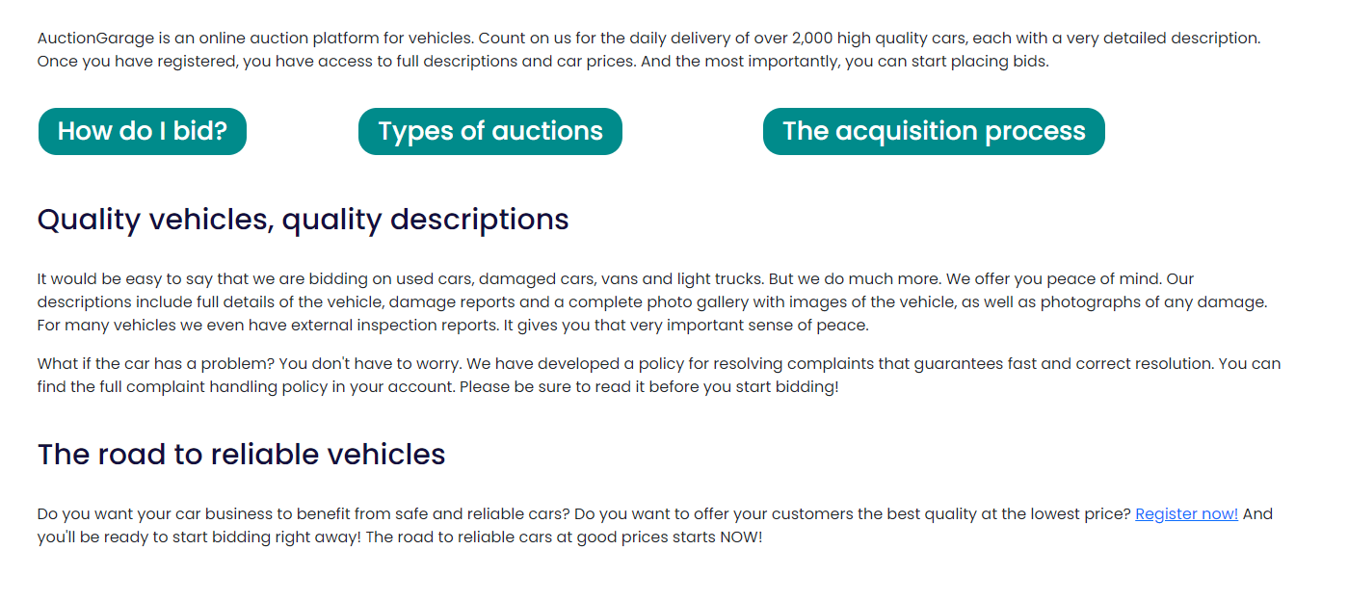

The review section consists of a container with 6 cards, 3 per 1 in a row. Each card contains the name and country of the customer, and his opinion about the company's services.



1. biddingprocess_page.html, biddingprocess_style.css

This page contains the navigation bar and the footer from the home page, and information about the AuctionGarage’s bidding process. To access this page, you have to press the button “How do I bid?” from the pagina1_findmore.html.

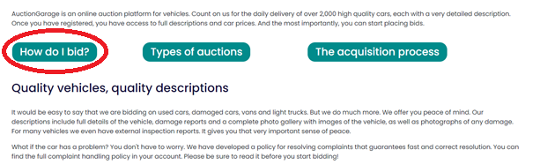

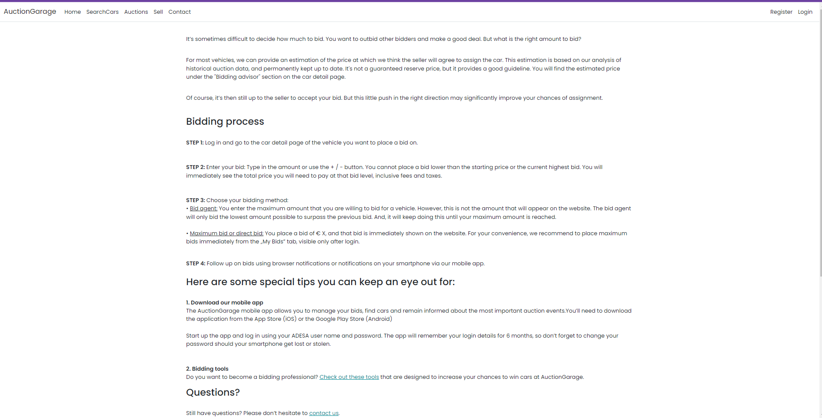

1. vehicle1.html, cars_style.css contains:

* navigation bar and footer from the home page
* a carousel made in Bootstrap which slides through 7 images with the car

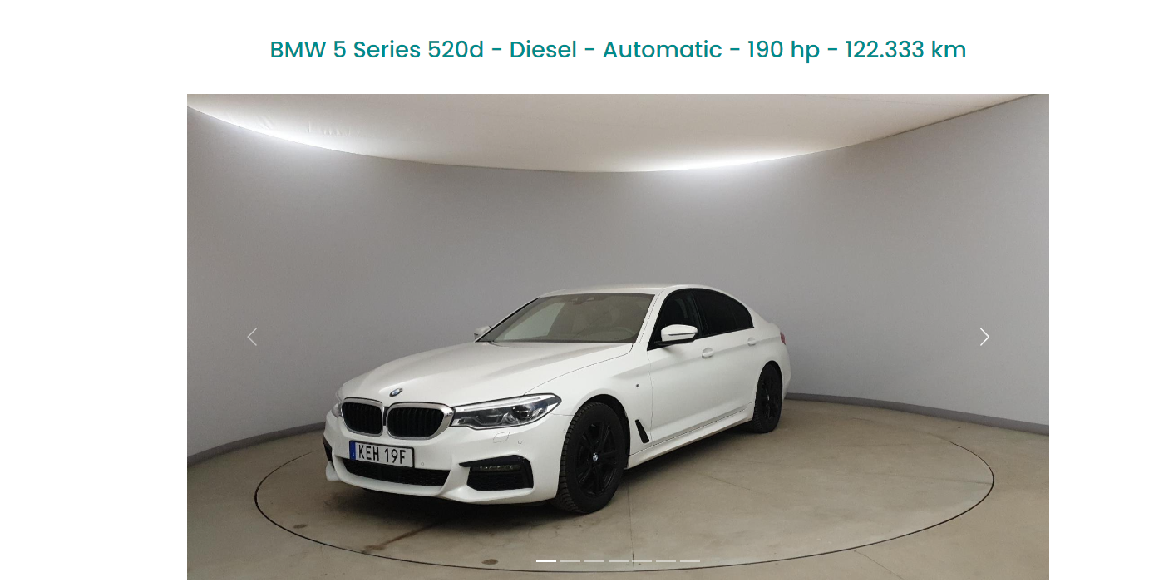

* 4 tables which contain information about the car’s specification, condition and origin

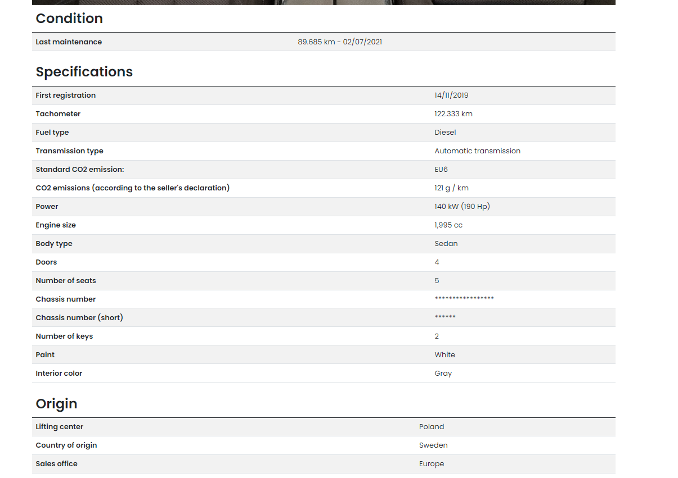

The code for the carousel:

<div id="carouselExampleIndicators" class="carousel slide" data-bs-ride="carousel">

            <div class="carousel-indicators">

                <button type="button" data-bs-target="#carouselExampleIndicators" data-bs-slide-to="0" class="active"

                    aria-current="true" aria-label="Slide 1"></button>

                <button type="button" data-bs-target="#carouselExampleIndicators" data-bs-slide-to="1"

                    aria-label="Slide 2"></button>

                <button type="button" data-bs-target="#carouselExampleIndicators" data-bs-slide-to="2"

                    aria-label="Slide 3"></button>

                <button type="button" data-bs-target="#carouselExampleIndicators" data-bs-slide-to="3"

                    aria-label="Slide 4"></button>

                <button type="button" data-bs-target="#carouselExampleIndicators" data-bs-slide-to="4"

                    aria-label="Slide 5"></button>

                <button type="button" data-bs-target="#carouselExampleIndicators" data-bs-slide-to="5"

                    aria-label="Slide 6"></button>

                <button type="button" data-bs-target="#carouselExampleIndicators" data-bs-slide-to="6"

                    aria-label="Slide 7"></button>

            </div>

            <div class="carousel-inner">

                <div class="carousel-item active">

                    <img src="image/1.jpg" class="d-block w-100" alt="...">

                </div>

                <div class="carousel-item">

                    <img src="image/2.jpg" class="d-block w-100" alt="...">

                </div>

                <div class="carousel-item">

                    <img src="image/3.jpg" class="d-block w-100" alt="...">

                </div>

                <div class="carousel-item">

                    <img src="image/4.jpg" class="d-block w-100" alt="...">

                </div>

                <div class="carousel-item">

                    <img src="image/5.jpg" class="d-block w-100" alt="...">

                </div>

                <div class="carousel-item">

                    <img src="image/8.jpg" class="d-block w-100" alt="...">

                </div>

                <div class="carousel-item">

                    <img src="image/9.jpg" class="d-block w-100" alt="...">

                </div>

            </div>

            <button class="carousel-control-prev" type="button" data-bs-target="#carouselExampleIndicators"

                data-bs-slide="prev">

                <span class="carousel-control-prev-icon" aria-hidden="true"></span>

                <span class="visually-hidden">Previous</span>

            </button>

            <button class="carousel-control-next" type="button" data-bs-target="#carouselExampleIndicators"

                data-bs-slide="next">

                <span class="carousel-control-next-icon" aria-hidden="true"></span>

                <span class="visually-hidden">Next</span>

            </button>

        </div>

    </div>

**References:**

* [**https://getbootstrap.com/docs/5.0/components/card/**](https://getbootstrap.com/docs/5.0/components/card/)
* [**https://getbootstrap.com/docs/5.0/components/carousel/**](https://getbootstrap.com/docs/5.0/components/carousel/)
* [**https://getbootstrap.com/docs/5.0/components/navs-tabs/**](https://getbootstrap.com/docs/5.0/components/navs-tabs/)
* [**https://getbootstrap.com/docs/5.0/components/buttons/**](https://getbootstrap.com/docs/5.0/components/buttons/)
* [**https://www.w3schools.com/html/html_responsive.asp**](https://www.w3schools.com/html/html_responsive.asp)
* [**https://www.youtube.com/watch?v=HuT-1ruVh5s&t=11s**](https://www.youtube.com/watch?v=HuT-1ruVh5s&t=11s)